Form of Passive
Subject + finite form of to be + Past Participle (3rd column of irregular verbs)
Example: A letter was written.
When rewriting active sentences in passive voice, note the following:
- the object of the active sentence becomes the subject of the passive sentence
- the finite form of the verb is changed (to be + past participle)
- the subject of the active sentence becomes the object of the passive sentence (or is dropped)

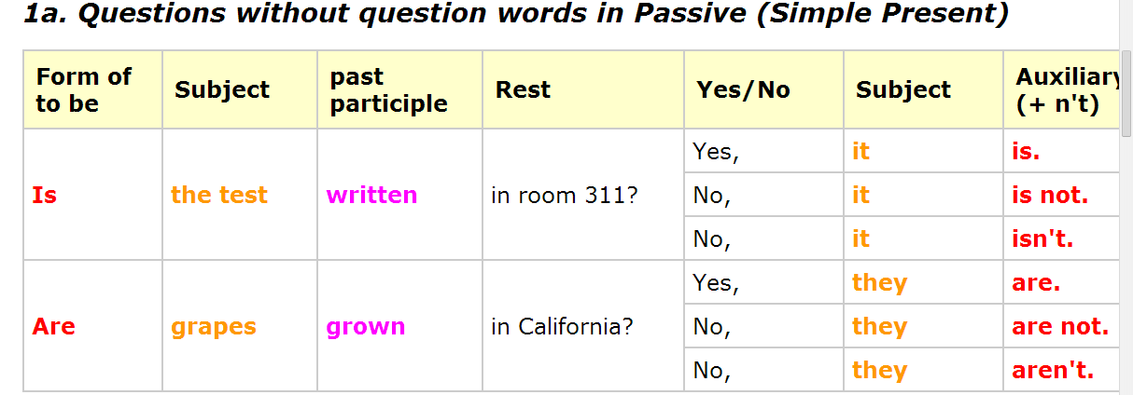
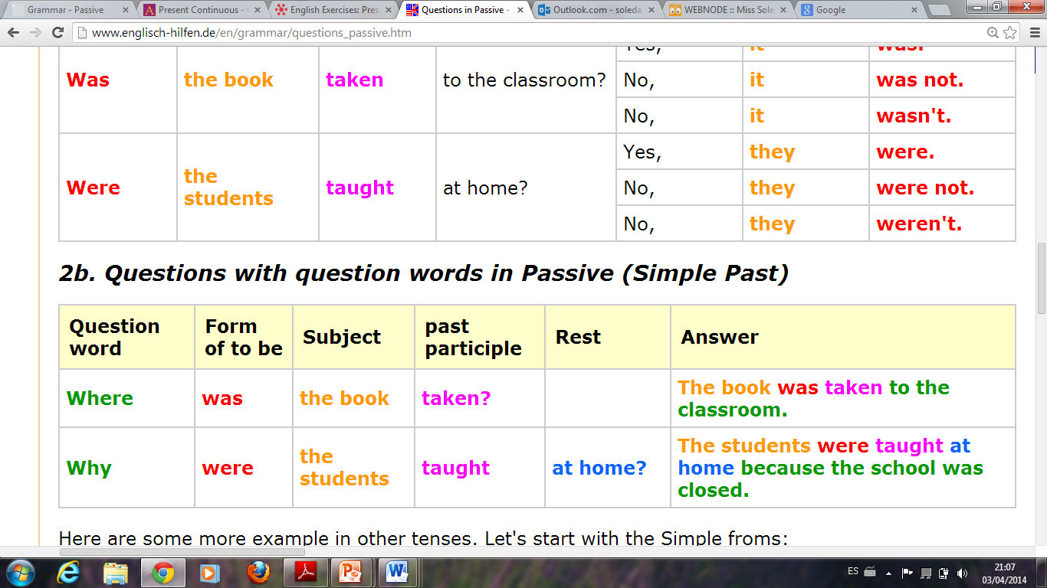
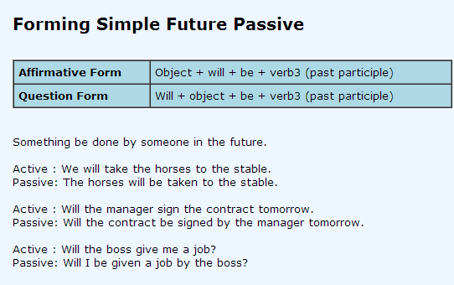
Exercises

http://www.ego4u.com/en/cram-up/grammar/passive/exercises?simple-present
http://www.ego4u.com/en/cram-up/grammar/passive/exercises?simple-past
http://www.ego4u.com/en/cram-up/grammar/passive/exercises?04
https://knowing-english.wikispaces.com/Passive+Voice
http://www.youtube.com/watch?v=PXS7Xgm2B-o

